Experiment No. 8
SEMESTER: V(2017-18) | DATE OF DECLARATION: 28/9/17
SUBJECT: CN | DATE OF SUBMISSION: 5/10/17
NAME OF THE STUDENT:MITCHELLE CREADO | ROLL NO.:14

Aim | To implement Dijkstra’s shortest path routing algorithm.
Learning Objective | The student will develop a logic for Dijkstra's shortest path algorithm.
Learning Outcome | The student will implement and apply Dijkstra's shortest path algorithm to a given network.
Course Outcome | C304.1 : Coceptualize all the OSI layers.  C304.3 : Analyze, compare and test datalink,network and transport layer protocol, algorithms, techniques in laboratory scenario.
Program Outcome | PO1: Apply the knowledge of mathematics, science, engineering, fundamentals, and an engineering specialization to the solution of complex engineering problem.  PO9: Function effectively as an individual, and as a member or leader in diverse teams, and in multidisciplinary settings.
Bloom's Taxonomy Level | Remember  Apply
Theory | The idea is to build a graph of the subnet, with each node of the graph representing a router and each arc of the graph representing a communication line (often called a link). To choose a route between a given pair of routers, the algorithm just finds the shortest path between them on the graph. The concept of a shortest path deserves some explanation. One way of measuring path length is the number of hops. Using this metric, the paths ABC and ABE in Fig. 8.1 are equally long. Another metric is the geographic distance in kilometers, in which case ABC is clearly much longer than ABE.  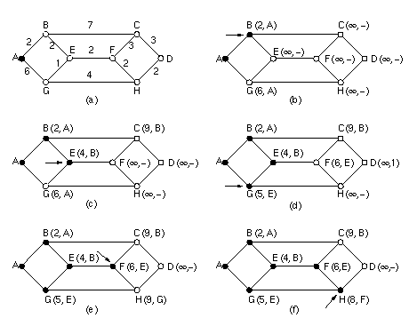  Figure 8.1 The first five steps used in computing the shortest path from A to D. The arrows indicate the working node.  However, many other metrics besides hops and physical distance are also possible. For example, each arc could be labeled with the mean queuing and transmission delay for some standard test packet as determined by hourly test runs. With this graph labeling, the shortest path is the fastest path rather than the path with the fewest arcs or kilometers.  In the general case, the labels on the arcs could be computed as a function of the distance, bandwidth, average traffic, communication cost, mean queue length, measured delay, and other factors. By changing the weighting function, the algorithm would then compute the ''shortest'' path measured according to any one of a number of criteria or to a combination of criteria.  Several algorithms for computing the shortest path between two nodes of a graph are known. This one is due to Dijkstra (1959). Each node is labeled (in parentheses) with its distance from the source node along the best known path. Initially, no paths are known, so all nodes are labeled with infinity. As the algorithm proceeds and paths are found, the labels may change, reflecting better paths. A label may be either tentative or permanent. Initially, all labels are tentative. When it is discovered that a label represents the shortest possible path from the source to that node, it is made permanent and never changed thereafter.  To illustrate how the labeling algorithm works, look at the weighted, undirected graph of Fig.8.1 (a), where the weights represent, for example, distance. We want to find the shortest path from A to D. We start out by marking node A as permanent, indicated by a filled-in circle. Then we examine, in turn, each of the nodes adjacent to A (the working node), relabeling each one with the distance to A. Whenever a node is relabeled, we also label it with the node from which the probe was made so that we can reconstruct the final path later. Having examined each of the nodes adjacent to A, we examine all the tentatively labeled nodes in the whole graph and make the one with the smallest label permanent, as shown in Fig. 8.1(b). This one becomes the new working node.  We now start at B and examine all nodes adjacent to it. If the sum of the label on B and the distance from B to the node being considered is less than the label on that node, we have a shorter path, so the node is relabeled. After all the nodes adjacent to the working node have been inspected and the tentative labels changed if possible, the entire graph is searched for the tentatively-labeled node with the smallest value. This node is made permanent and becomes the working node for the next round. Figure 8.1 shows the first five steps of the algorithm.  To see why the algorithm works, look at Fig.8.1(c). At that point we have just made E permanent. Suppose that there were a shorter path than ABE, say AXYZE. There are two possibilities: either node Z has already been made permanent, or it has not been. If it has, then E has already been probed (on the round following the one when Z was made permanent), so the AXYZE path has not escaped our attention and thus cannot be a shorter path.  Now consider the case where Z is still tentatively labeled. Either the label at Z is greater than or equal to that at E, in which case AXYZE cannot be a shorter path than ABE, or it is less than that of E, in which case Z and not E will become permanent first, allowing E to be probed from Z.
Lab Activities | - Develop a java program for Dijkstra’s shortest path routing algorithm.  import java.util.*;  class Node  {  public int label; // this node's label (parent node in path tree)  public int weight; // weight of edge to this node (distance to start)  public Node(int v, int w)  {  label = v;  weight = w;  }  }  public class ShortestPath  {  public static Scanner in; // for standard input  public static int n, m; // n = #vertices, m = #edges  public static LinkedList[] graph; // adjacency list representation  public static int start, end; // start and end points for shortest path  public static void main(String[] args)  {  in = new Scanner(System.in);  // Input the graph:  System.out  .println("Enter the number of components and wires in a circuit:");  n = in.nextInt();  m = in.nextInt();  // Initialize adjacency list structure to empty lists:  graph = new LinkedList[n];  for (int i = 0; i < n; i++)  graph[i] = new LinkedList();  // Add each edge twice, once for each endpoint:  System.out  .println("Mention the wire between components and its length:");  for (int i = 0; i < m; i++)  {  int v1 = in.nextInt();  int v2 = in.nextInt();  int w = in.nextInt();  graph[v1].add(new Node(v2, w));  graph[v2].add(new Node(v1, w));  }  // Input starting and ending vertices:  System.out  .println("Enter the start and end for which length is to be minimized: ");  start = in.nextInt();  end = in.nextInt();  // FOR DEBUGGING ONLY:  displayGraph();  // Print shortest path from start to end:  shortest();  }  public static void shortest()  {  boolean[] done = new boolean[n];  Node[] table = new Node[n];  for (int i = 0; i < n; i++)  table[i] = new Node(-1, Integer.MAX_VALUE);  table[start].weight = 0;  for (int count = 0; count < n; count++)  {  int min = Integer.MAX_VALUE;  int minNode = -1;  for (int i = 0; i < n; i++)  if (!done[i] && table[i].weight < min)  {  min = table[i].weight;  minNode = i;  }  done[minNode] = true;  ListIterator iter = graph[minNode].listIterator();  while (iter.hasNext())  {  Node nd = (Node) iter.next();  int v = nd.label;  int w = nd.weight;  if (!done[v] && table[minNode].weight + w < table[v].weight)  {  table[v].weight = table[minNode].weight + w;  table[v].label = minNode;  }  }  }  for (int i = 0; i < n; i++)  {  if (table[i].weight < Integer.MAX_VALUE)  {  if(i==end)  {  System.out.print("Wire from " + i + " to " + start + " with length " + table[i].weight + ": ");  }  int next = table[i].label;  while (next >= 0)  {  if(i==end)  {  System.out.print(next + " ");  }  next = table[next].label;  }  System.out.println();  }  else  System.out.println("No wire from " + i + " to " + start);  }  }  public static void displayGraph()  {  for (int i = 0; i < n; i++)  {  System.out.print(i + ": ");  ListIterator nbrs = graph[i].listIterator(0);  while (nbrs.hasNext())  {  Node nd = (Node) nbrs.next();  System.out.print(nd.label + "(" + nd.weight + ") ");  }  System.out.println();  }  }  }  - Draw a network for your example.(Each student will have different network).  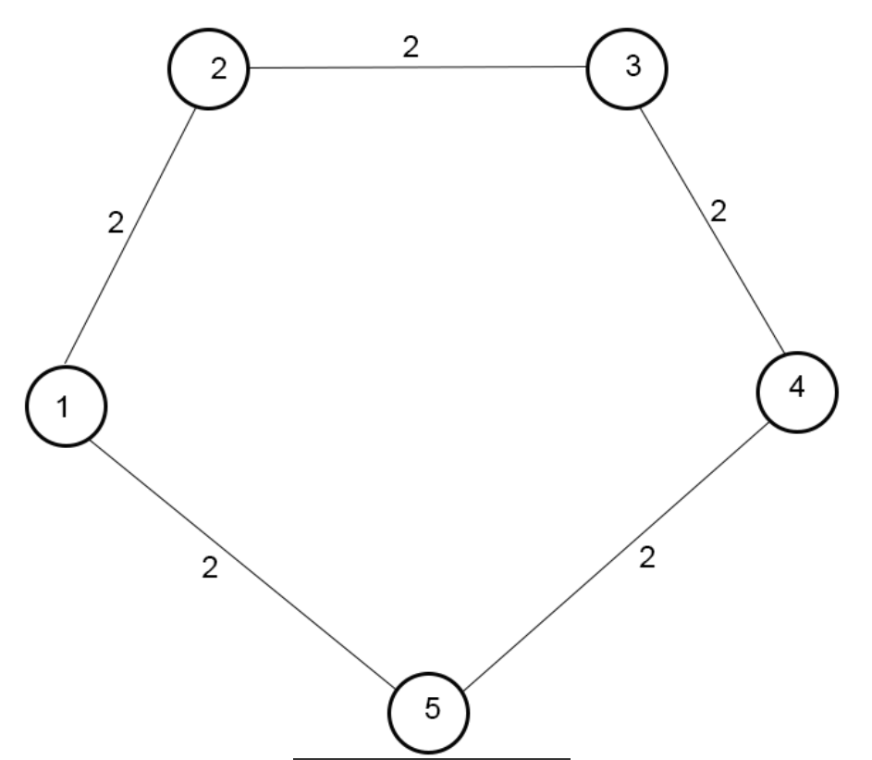  Shortest path:  Start node:1  End node: 4  Path 1-5-4  Distance-4  - Attach the output for your network.  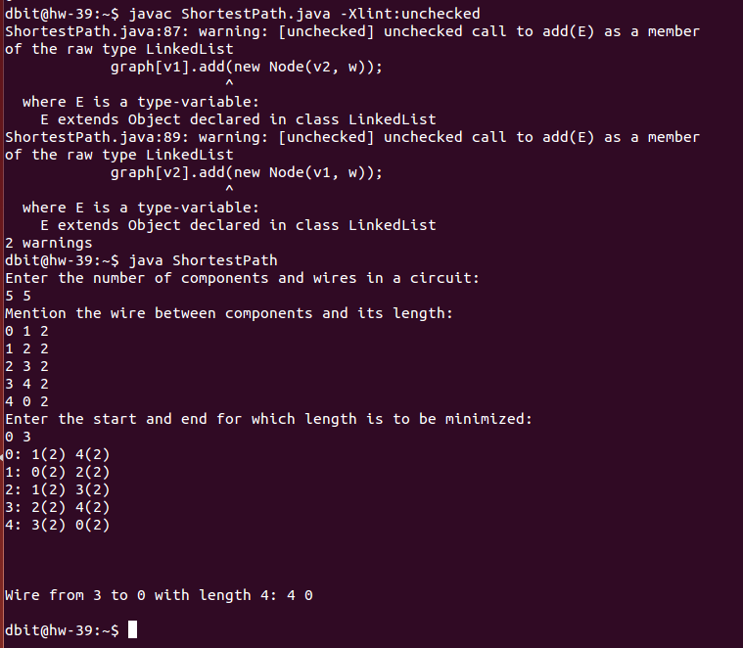
Conclusion | Thus we implement the shortest path first algorithm and find the path from the starting node to the ending node.
References | - B.A. Forouzan, “Data Communications and Networking”, TMH, Fourth Edition

